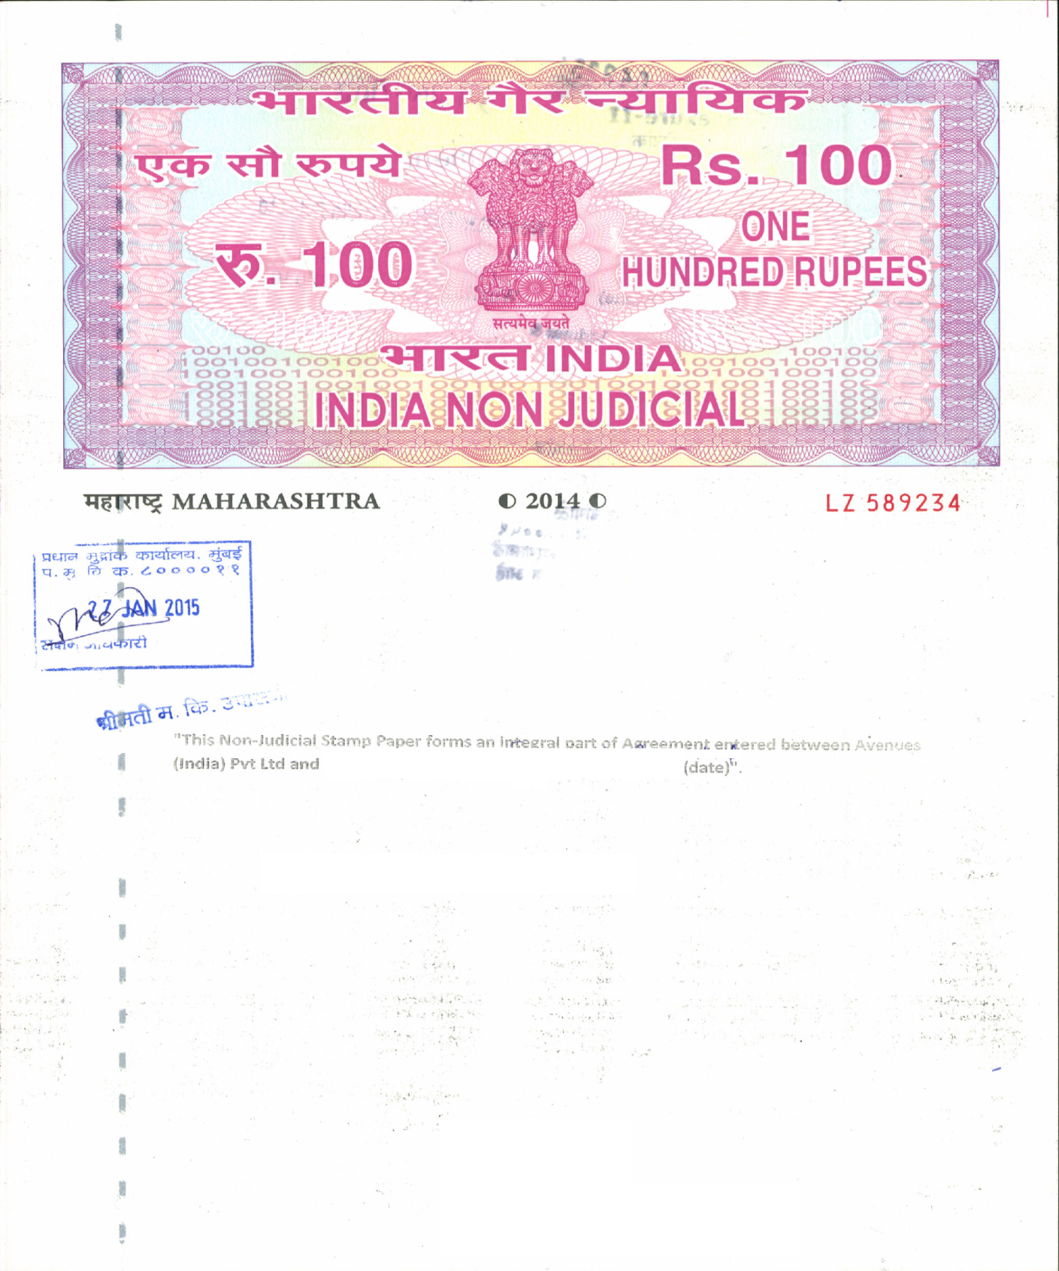

**Signature with Sole proprietor/Private Ltd/Partner Stamp**

**This Non-Judicial Stamp Paper forms an integral part of the Avenues India Pvt Ltd. Internet Gateway Merchant Legal Agreement executed by ______________________ (name) on ____________(date)**

Attach separately **Non-Judicial stamp paper for the value of Rs 300  
(100rs three Stamp Paper) OR Franked for the value of Rs 300/-** 

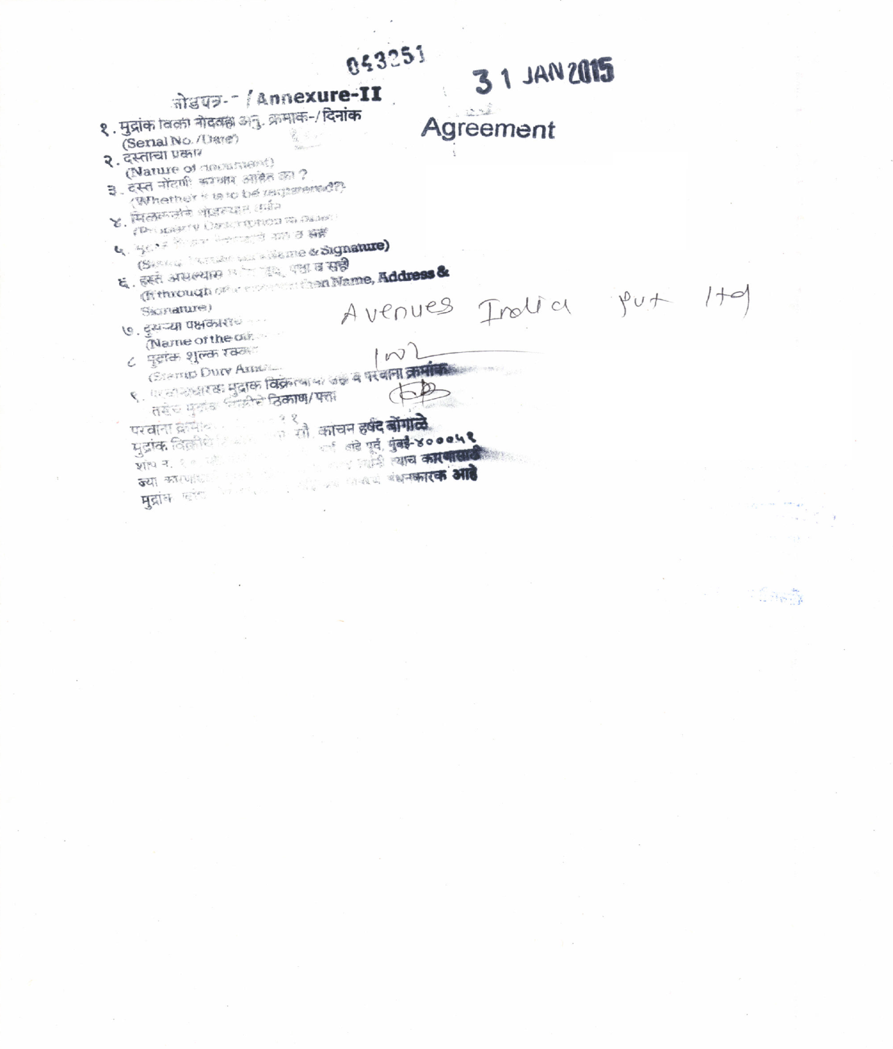

**COMPANY NAME**

**Second Party Name: - Avenues India Pvt Ltd**

**First Party Name**

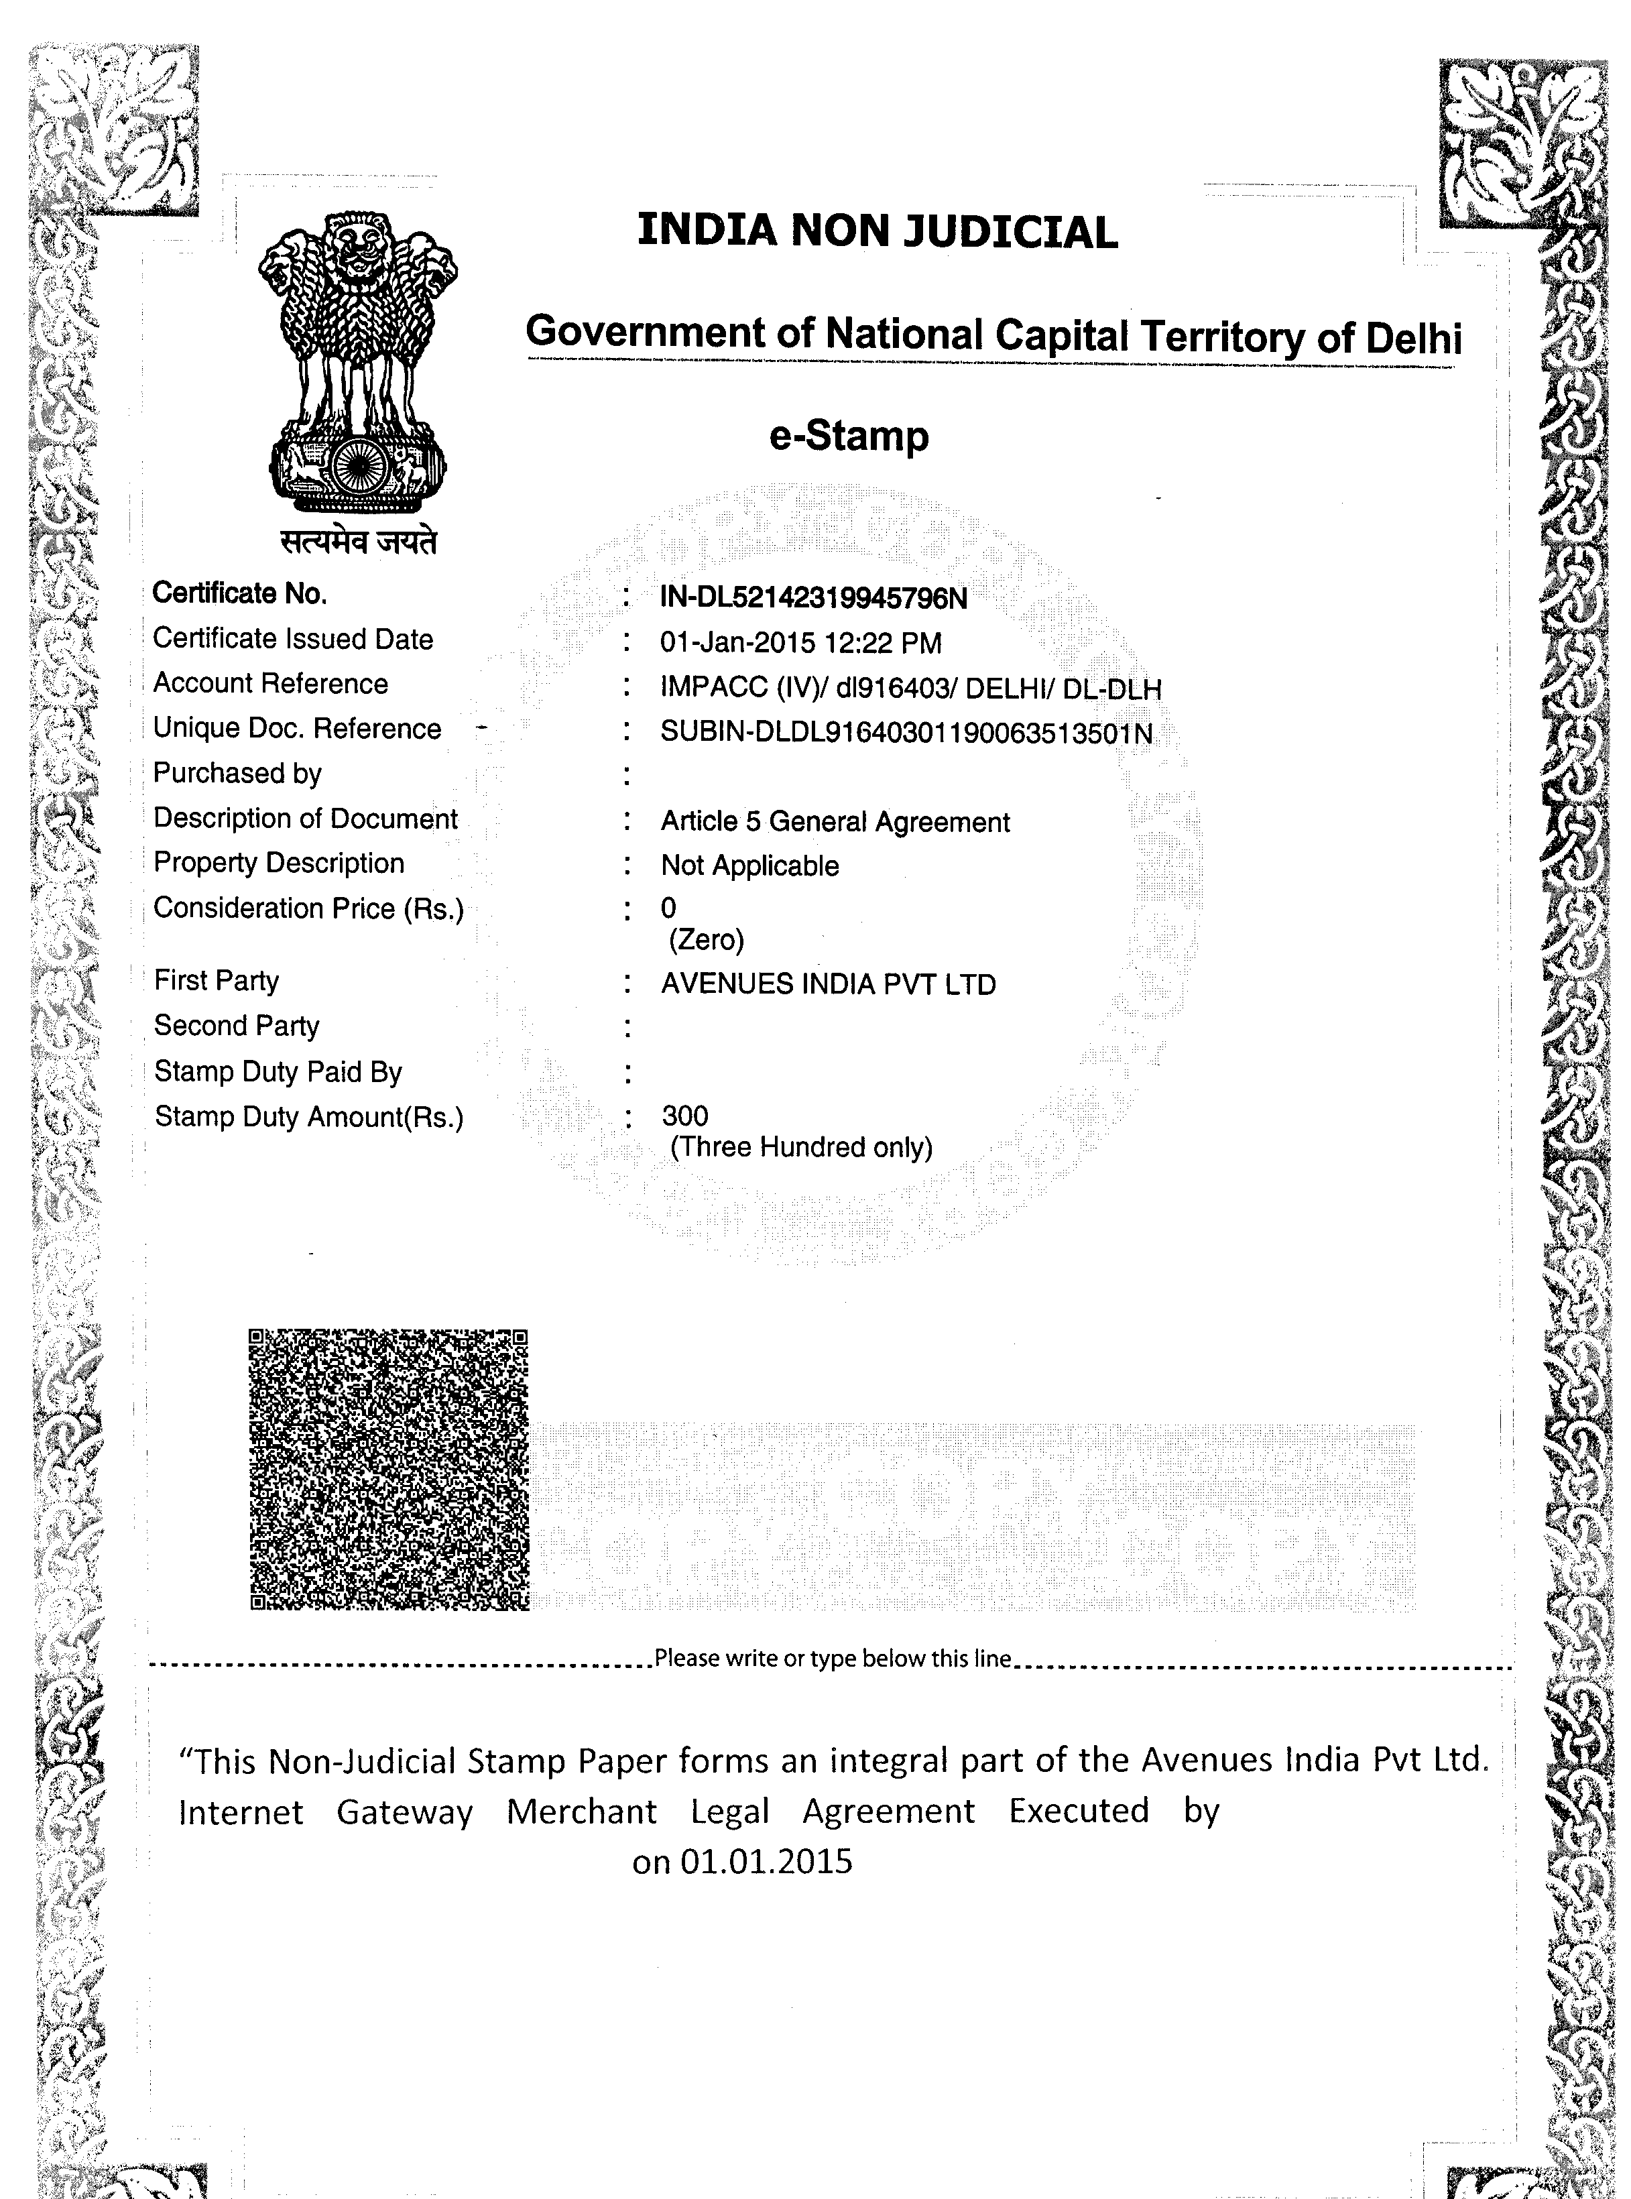Attach separately **Non-Judicial stamp paper for the value of Rs 300  
(100rs three Stamp Paper) OR Franked for the value of Rs 300/-**   
**(FRANKING)**

**Signature with Sole proprietor/Private Ltd/Partner Stamp**

**E-STAMP PAPER**

**Company Name**

**Company Name**

**Clear Watermark**

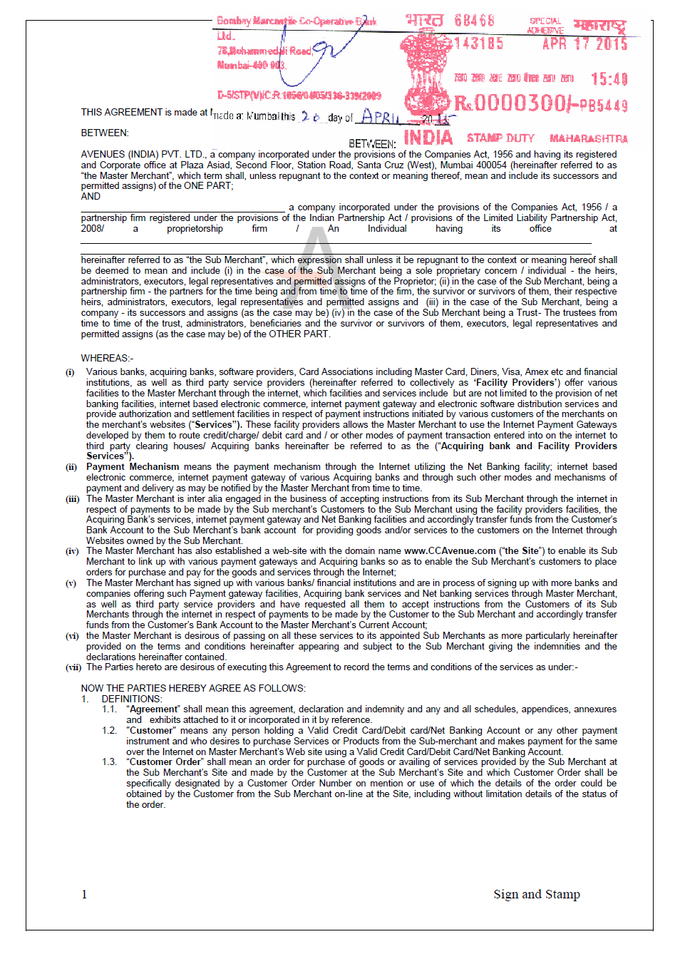

**Signature with Sole proprietor/Private Ltd/Partner Stamp**

**Franked for the value of Rs. 300**